# CS 255 System Design Document Template

Travis London

08/17/2024

## UML Diagrams

### UML Use Case Diagram

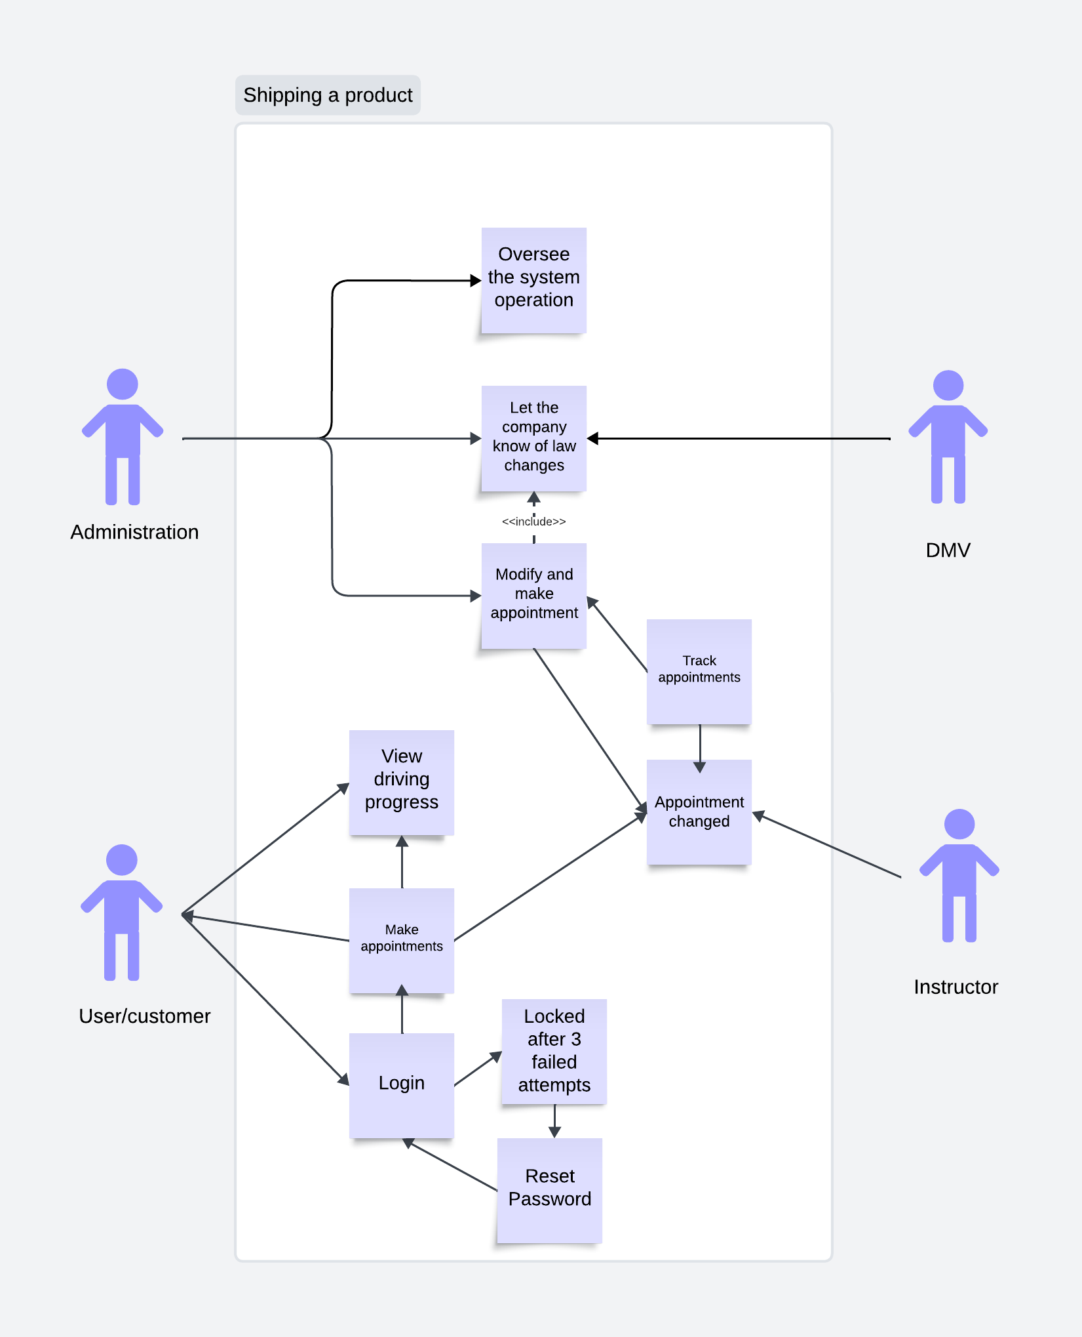

### UML Activity Diagrams

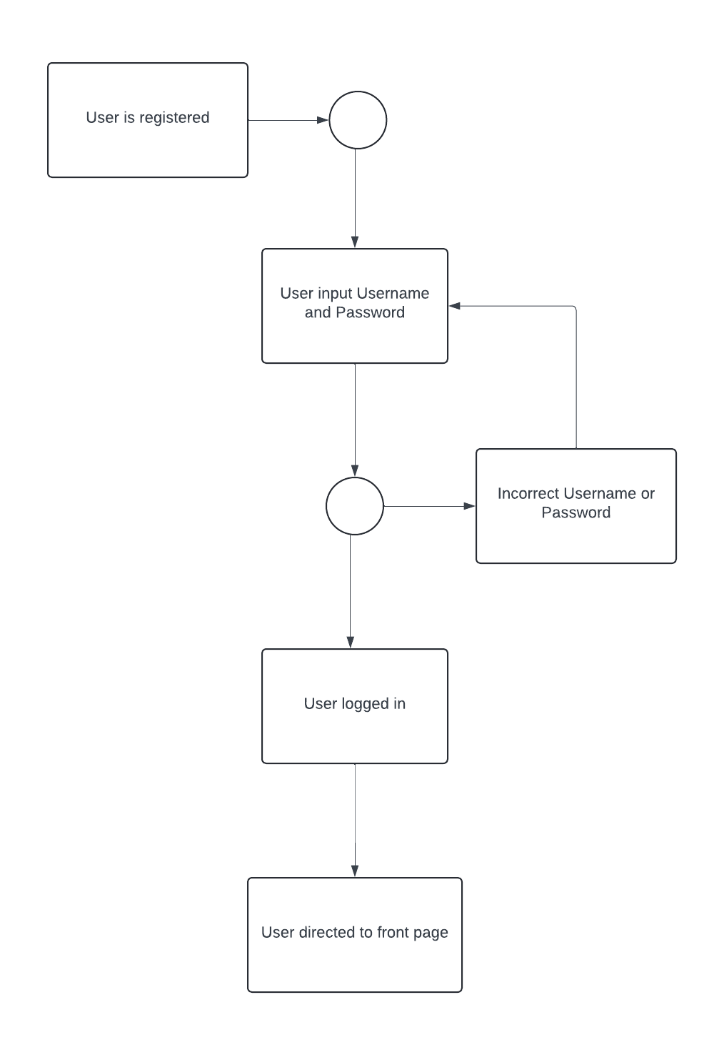

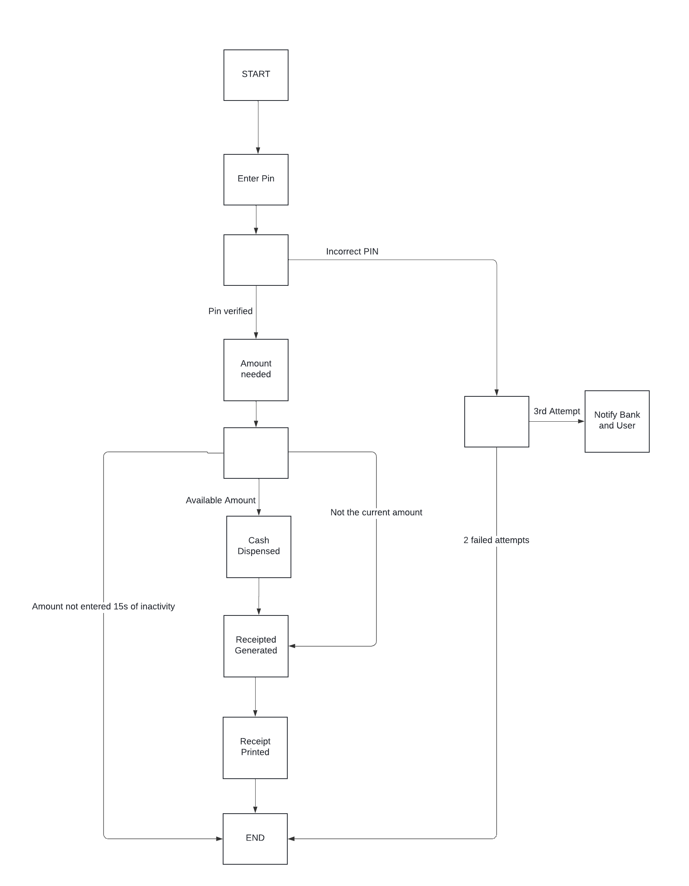

### UML Sequence Diagram

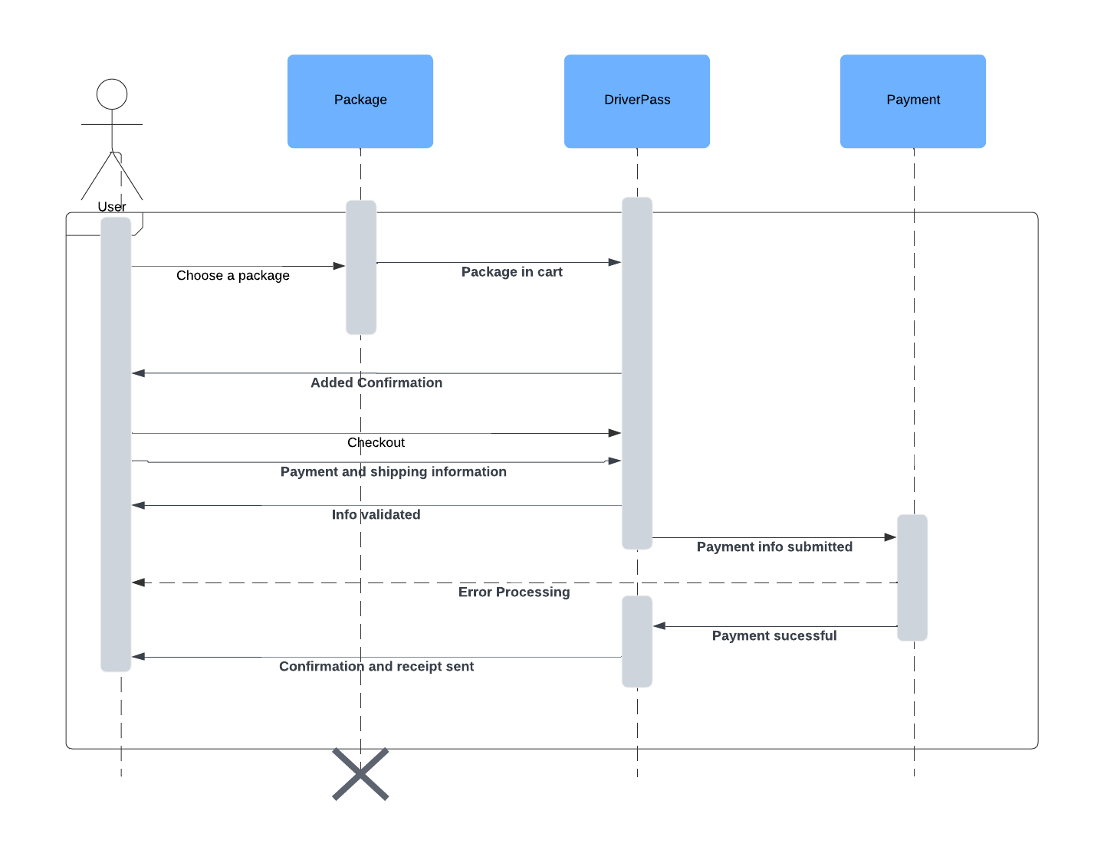

## Technical Requirements

Hardware requirements for Host:

* Minimum requirement one physical server
* Cables for the server and equipment
* Power sources
* Internet provider

Hardware requirement Client:

* Desktop or Laptop
* Modem or WI-FI and ethernet cable
* Power sources
* Internet provider

Software Requirements Host and client:

* DriverPass
* Security software
* Windows or MacOS operating software